**Module 8 – Portfolio Milestone**

Dominic A. Suarez

Colorado State University Global

CSC 500-1: Principles of Programming

Dr. Lori Farr

April 7, 2024

**Module 8 Portfolio Project**

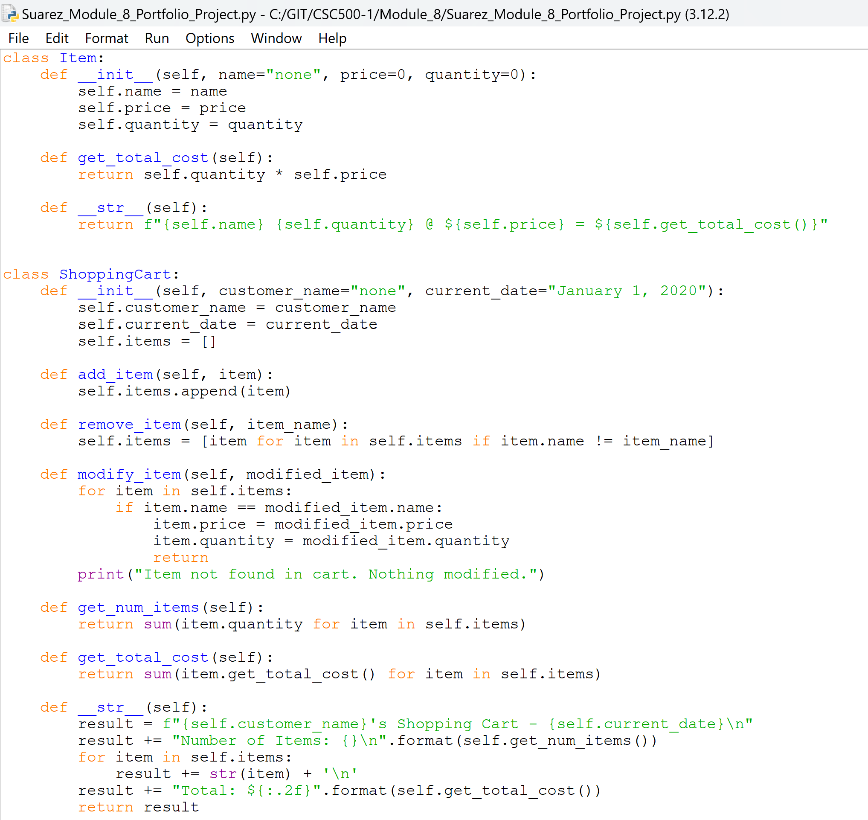

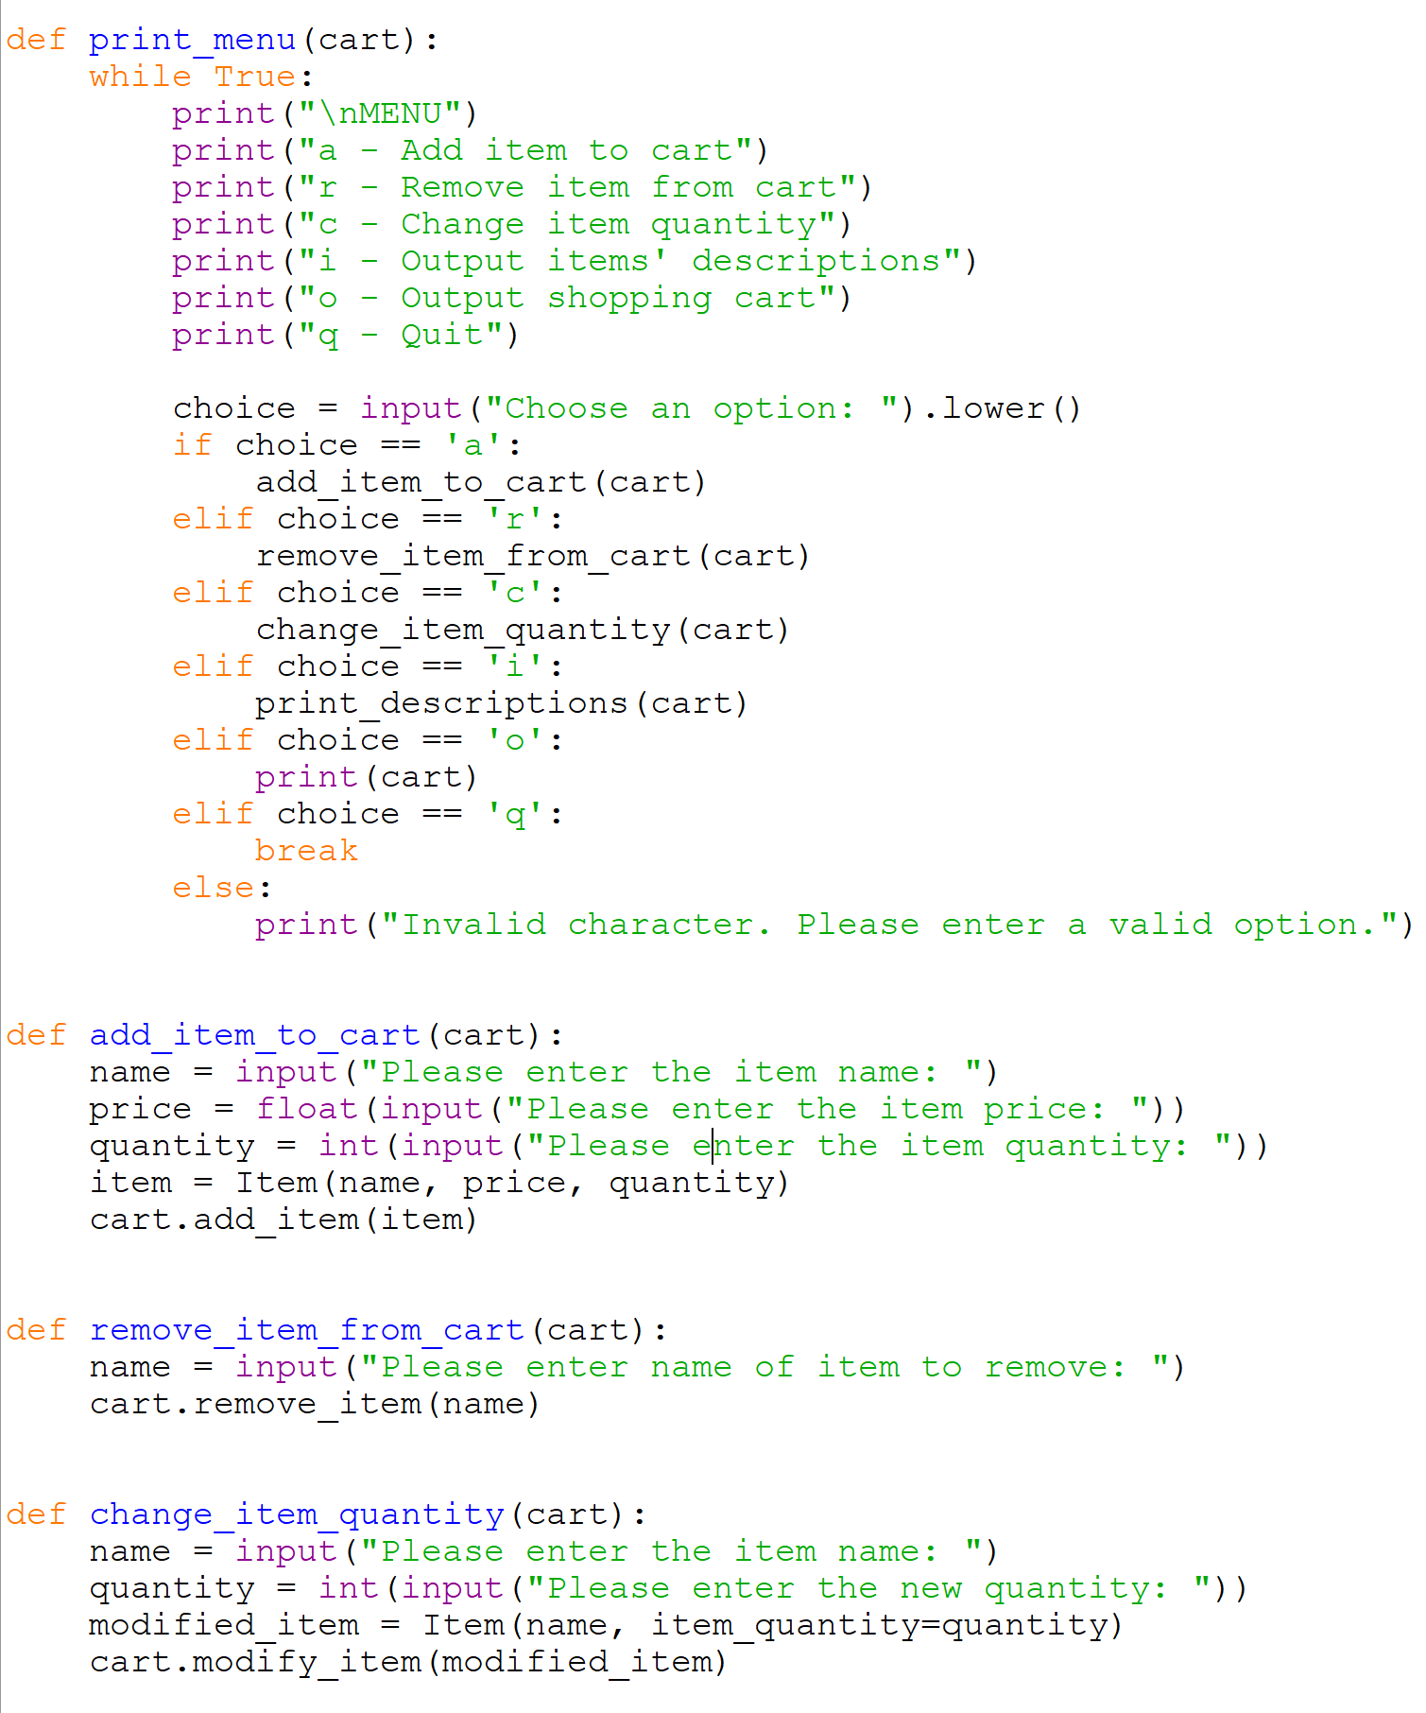

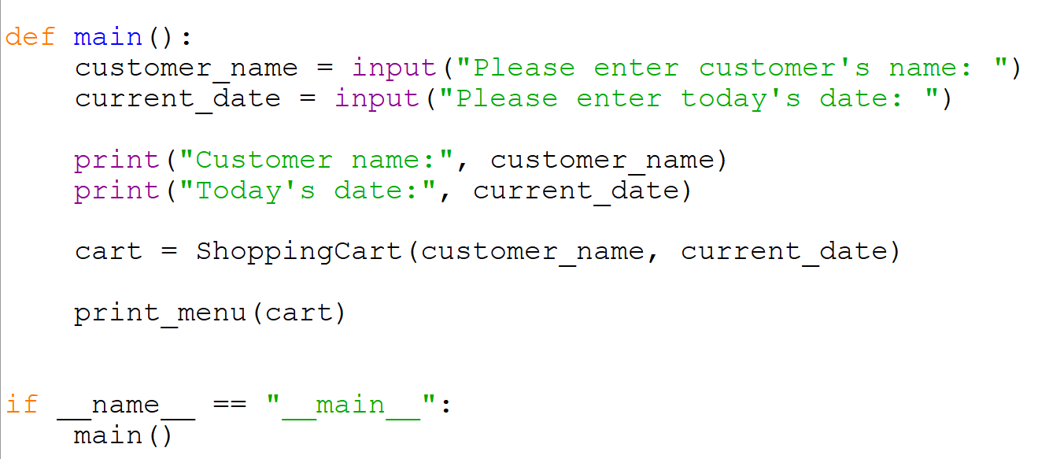

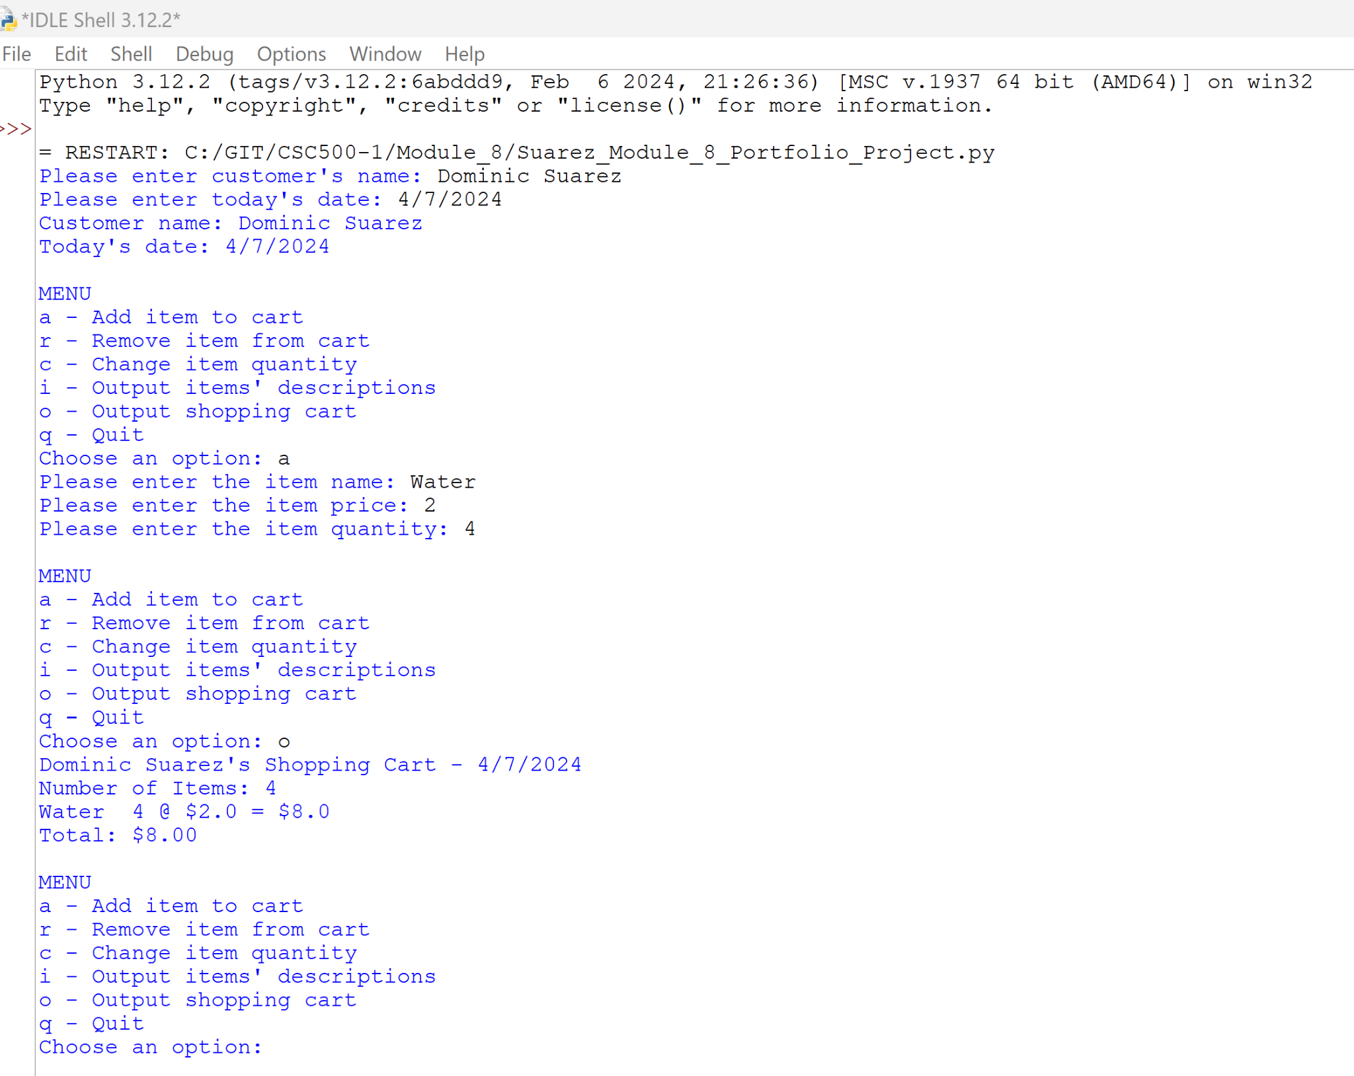

*Git repository is found at https://github.com/dominic-suarez/CSC500-1*